16.12: 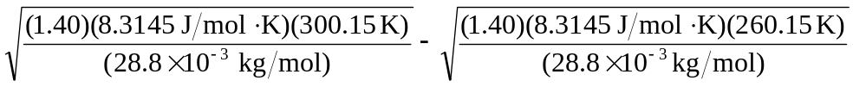
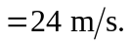

(The result is known to only two figures, being the difference of quantities known to three figures.)

